

Dear Guest,

Welcome to Novotel Sharm El Sheikh Beach Resort!

Novotel Sharm El Sheikh is a premium resort that became a landmark in the destination through unique location, services and facilities. Peaceful atmosphere and warm hospitality make any stay an unforgettable experience.

Please be informed that you will enjoy the following during your stay on all Inclusive basis and our team will be at your disposal at any time to answer your specific requests.

RESTAURANTS & BARS:
- Coral Restaurant :
Located in the Beach side of the hotel. Breakfast, lunch and dinner.

Breakfast : from 06:30 to 10:00
Weekend : from 06:30 to 10:30
Lunch : from 12:30 to 15:00
Dinner : from 18:30 to 21:30

Food to be consumed only inside the restaurant and dishes not be taken out of the venue

AL Carte Restaurants:
(AL Dente Italian & Al Sharqi Oriental Restaurants) located directly on the beach. (Against Charge) Open from 12:30 to 17:30 and from 19:00 to 23:00.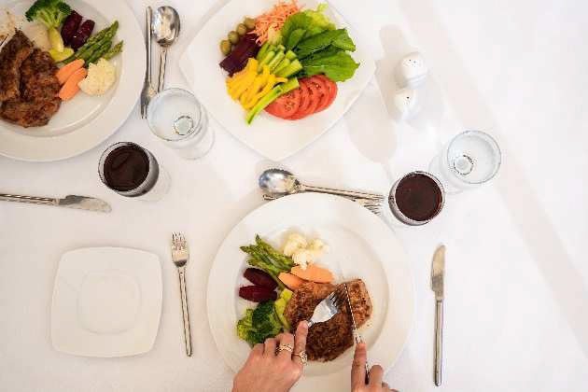

POOL BAR: Located near to the beach open from 10:00 to 23:00.

BEACH BAR: Located directly on the hotel beach open from 10:00 to sunset.

SNACKS:
Food and beverages refreshers are presented by the Beach bar from 15:30 till 17:00 at beach snacks area

Happy Hour: from 16:30 to 18:30

BEVERAGES:
A water bottle as well as soft / hot drink or a juice are presented with every guest’s meal at the meal venue.
Soft drinks, canned juices, Nescafe, Tea, Hot chocolate are served (by glass).
Locally produced beverages are included in all outlets during their individual opening hours
Local spirits (Gin, Vodka, Rum, Whiskey, Tequila, Sakkara draft beer) Local wine served by glass in the Dinning venue during lunch and dinner time.

Espresso coffee, freshly squeezed juices, all imported alcohol, imported wines and Champaign- are available against charge

KIDS’ MEALS:
Kids are enjoying their kid’s menus with its rich and varied items (Pizza, mini burger, chicken fillets) at the same operating hours of VIP Lounge.
NOVOTEL Beach All Inclusive Formula

Service/ Activities available at charge:
  - Room Service 24 hours
  - Al Dente Italian & Al Sharqi Oriental Restaurants (Lunch and dinner) a la carte
  - Mini Bar upon request
  - Laundry and press service

Room notes:
  - Free coffee tray offered with a daily replenish in all guest rooms.
  - Four complimentary water bottles per room replenished daily.
  - Digital safe box is available in all guest rooms
  - Bathrobes are available in the guest room upon request.
  - Iron and ironing machine is available upon request.

Entertainment:
  - Movie nights besides Sports matches broadcasting are available in the pool bar terrace on daily basis.
  - Gym is working 24/7
  - Spa from 08:00 to 21:00
  - Tennis (against Charge ) for booking please contact reception

Kids Club

Located at the Novotel Palm Area. Welcome all children from 04 to 12 years old

Handcraft activities, pool and beach games, accrobranching. Rollers, drawing and painting, circus school, origami, bingo, etc.

Open from 09:00 to 12:00 and from 14:00 to 16:30

Mini disco at 20:30 daily at Novotel Beach in the pool bar area and Novotel Palm

Medical Service:
Hotel doctor is available on call 24 hours. Doctor visit for charge excluding medicine. Please call reception

